5. MAXIMA AND MINIMA
Critical Point: Point at slop is not defined and point at which f’(x) = 0. Hence, f’(x) is 0 or undefined.
Extreme Value Theorem:
For a continuous function f(x) on [a, b] there exists Maxima and Minima.
- The maxima and minima values occur at either at the end point or at the critical point (f’(x) = 0).
For a continuous function f(x) on (a, b), maxima or minima may or may not exist.
- If maxima or minima exists, then will occur only at critical point.
Concave Up/Down:  Cone Cave  Absolute/Local Maxima/Minima:  Local Maxima/Minima: x at f’(x) = 0  Point of Inflection:  Point on the graph of a function at which concavity changes from up to down or vice versa.  1. f’’(x) = 0  2. f’’(x) should switch it’s sign about the inflection point.  No maxima or No minima at point of inflection. | 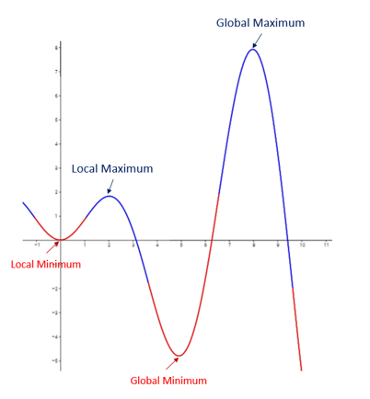
Maxima And Minima For Function Of Two Variable:
Let $f\left(x, y\right)$ be the function of two variable for which maxima and minima is to be determined.
$$Let, p=\frac{∂f}{∂x}, q=\frac{∂f}{∂y}, r=\frac{∂^{2}f}{∂x^{2}}, s=\frac{∂^{2}f}{∂x ∂y}, t= r=\frac{∂^{2}f}{∂y^{2}}$$
- Find p, q, r, s, t.
- Obtain stationary points by evaluating p and q to zero.
- Find r, s, t at stationary points.
Concluding Remarks:
- If $rt-s^{2}>0$, and $r>0$, f (x, y) has Minimum at that stationary points.
- If $rt-s^{2}>0$, and $r<0$, f (x, y) has Maximum at that stationary points.
- If $rt-s^{2}<0$, there is no extremum at that stationary points and such that point is called saddle points.
- If $rt-s^{2}=0,$ test is un-conclusive. Need to go with higher order derivative.
All critical points are not stationary points but all stationary points are critical points.
Lagrange Multiplier (Constrained Optimisation):
Type of Constrain
Unconstrained Optimization | Inequality Constrained Optimization | Equality Constrained Optimization
When we want to Maximise (or Minimise) $f\left(x, y,z\right),$
Subjected to constrain that $g\left(x, y,z\right)=c,$
Follow these steps,
- Introduce a new variable λ and defined a new function $L$ as follows;
$$L=f\left(x, y,z\right)-λ\left(g\left(x, y,z\right)-c\right)=0$$
This function is called Lagrangian, and new variable is referred as Lagrange multiplier.
- Set gradient of $L$ equal to zero vector. $∇L\left(x,y,z,λ\right)=0$
In other words, find the stationary points of $L$.
- Consider each solution, substitute it in f.
Whichever one gives the greatest (or smallest) value is the maximum (or minimum) point you are seeking.

Solution of function: ax² + bx + c
$$x= \frac{-b±\sqrt{b^{2}-4ac}}{2a},x_{1}+x_{2}= \frac{-b}{a}, x_{1}x_{2}= \frac{c}{a}$$

